Power Asymmetries on International Organizations
Manas Reddy
Baylor University
PSC 2301 Research Methods
Dr. Flavin
Dec 16th, 2024

Abstract
How do internal power dynamics within international organizations (IOs) affect their effectiveness in mediating civil conflicts and the durability of post-conflict peace agreements? This paper argues that IOs with high power asymmetries, where a small group of dominant member states exert disproportionate influence, are less likely to achieve lasting conflict resolution outcomes. Looking at scholarly literature about IO design, conflict mediation, and regime theory, I hypothesize that IOs with more power differences will lead to fewer peace settlements and lessened peace longevity. To test this hypothesis, I combined data from the publicly accessible Intergovernmental Organizations (IGO) dataset and the Uppsala Conflict Data Program (UCDP), operationalizing effectiveness through quantifiable mediation outcomes and stability indicators. Using regression analysis, I find that IO interventions showing balanced internal power distributions correlate with more durable peace agreements. These results suggest the need for institutional reforms to mitigate the influence of dominant states within IOs.

Introduction
International organizations (IOs) are important in managing civil conflicts. They offer platforms for negotiation, allocate resources for peacebuilding, and provide neutral spaces for warring parties to come to the table. Yet IOs often vary dramatically in their ability to translate these intentions into lasting resolutions. A central, but sometimes overlooked, factor shaping IO performance is the internal distribution of power among member states. When a handful of dominant states hold disproportionate sway, their strategic interests may affect the mediation process.
Understanding the role of power asymmetry within IOs is crucial because ineffective mediation not only causes more violence, but also diminishes trust in international governance structures. If we know how power imbalances affect IO interventions, we can recommend institutional reforms to enhance their credibility and improve outcomes. The stakes are high: civil conflicts destabilize regions, spur refugee crises, and threaten global security. This research will help advance our knowledge of how IO structures influence conflict management success.

Research Question
How do internal power dynamics and resource allocation strategies within international organizations (IOs) influence their effectiveness in mediating civil conflicts, particularly in cases where member states hold conflicting interests, and how does this impact the durability of peace agreements in post-conflict states?

Literature Review
Existing research on IO involvement in conflict resolution generally emphasizes the importance of institutional structures, membership cohesiveness, and capacity for effective mediation. Boehmer, Gartzke, and Nordstrom (2004) show that certain IOs can promote peace, suggesting that more cohesive and institutionally robust IOs reduce the likelihood of militarized disputes. This emphasis on organizational structure aligns with Abbott and Snidal’s (1998) argument that states act through IOs to achieve centralized and neutral conflict management, although such neutrality may be compromised by powerful states’ interests. Wallensteen and Svensson (2014) highlight the effectiveness of facilitative and communicative mediation strategies, suggesting that IO legitimacy and impartiality contribute to more durable outcomes. However, Mele, Anderfuhren-Biget, and Varone (2015) reveal that IO staff can experience conflicts of interest influenced by their home states, pointing to the challenge of internal power pressures on operational impartiality. Lundgren (2016) provides a dataset (IOCM) showing that over time, IOs have improved their conflict management capabilities. Still, these gains may be reliant on the way the organization distributes its power. Haas (1983) explains that regime decay can occur when IOs fail to manage internal and external pressures, implying that over time, dominant member influence could erode IO effectiveness. Chu and Taqa (2015) emphasize IO adaptability in the face of geopolitical tensions, while Kabore (2023) demonstrates how IO roles in specific contexts depend on balancing member interests with mediation integrity.
Looking at all of this literature, it is clear that a gap remains in researching power asymmetry within IO membership to quantifiable mediation. Although previous studies note the importance of organizational structure, few employ measures of internal power concentration, nor do they explore how this asymmetry affects long-term peace durability. By focusing on power asymmetry and employing both regression and survival analyses, this study advances the field, offering a more nuanced understanding of how IO internal configurations shape mediation effectiveness.

Theoretical Expectations
Drawing on theories of institutional design and power politics, this study hypothesizes that IOs in which a few powerful states wield greater influences are less effective mediators. High power asymmetry can lead to biased decision-making, delayed interventions, or ineffective enforcement measures, as dominant members pursue their interests at the expense of collective conflict resolution goals. In contrast, IOs with more balanced power distributions are better positioned to appear more impartial, allocate resources equitably, and implement more fair policies. These theoretical expectations suggest that IOs with strong institutional frameworks can more effectively mediate and even prevent civil conflicts, while those constrained by internal hierarchies may produce peace agreements that fail to endure. Thus, IO power dynamics shape not only immediate mediation success, but also the stability of settlements well into the post-conflict era.

Variables
Dependent Variable: The effectiveness of IO mediation is assessed through measurable outcomes:
- Peace Agreement Success: Whether a formal peace agreement was reached.
- Conflict Intensity Reduction: Changes in conflict intensity following IO intervention.
- Post-Conflict Stability: The durability of peace agreements over time.
Independent Variable: Power Asymmetry within IOs.
- This is measured via the Herfindahl Index, which captures the concentration of influence among member states.
These variables are operationalized as follows:
- Power Asymmetry (Herfindahl Index): Calculated annually at the IO level, with higher scores indicating greater concentration of power.
- Mediation Effectiveness (Dependent): Derived from UCDP Peace Agreements (to gauge success and longevity) and the intensity metrics from conflict datasets.

NOTE: By linking the Herfindahl Index to subsequent mediation outcomes, the analysis can isolate the effect of internal power dynamics with the ability of an IO in conflict resolution.

Hypothesis
Higher power asymmetry negatively impacts International Organization’s mediation effectiveness.

Data Description
To test this hypothesis, three primary datasets are utilized:
- IGO-Year Dataset: This dataset records annual membership changes, voting arrangements, funding contributions, and other institutional characteristics of IOs. From these data, the Herfindahl Index is computed to quantify power asymmetry.
- UCDP Peace Agreements Dataset: This dataset tracks the signing, type, and durability of peace agreements. It allows for the assessment of whether mediation efforts lead to formal, lasting settlements.
- UCDP Armed Conflict Dataset: The conflict dataset provides information on conflict intensity, type, and duration. Linking these data with IO interventions enables the evaluation of mediation outcomes in terms of reduced violence and sustained stability.
Potential Measurement Limitations: Looking at the IO’s effectiveness is challenging due to varying definitions of “success.” Also, power asymmetry may miss other types of influences. Cross-referencing multiple data sources and integrating various types of indicators helps mitigate these concerns.

Methodology:
A multi-step quantitative approach is employed:
- Regression Analysis:
Ordinary least squares (OLS) and logistic regression models test the effect of power asymmetry on mediation outcomes (e.g., whether a peace agreement was reached, reduction in conflict intensity). Control variables include conflict type (ethnic, ideological) and agreement type (comprehensive, partial), as these factors can shape mediation success independently.
- Kaplan-Meier Survival Analysis:
To assess how IO power asymmetry influences the durability of peace agreements over time, survival analysis estimates the probability that a peace agreement remains intact. Kaplan-Meier curves compare IOs stratified by power asymmetry quartiles, revealing whether balanced power distributions correlate with prolonged post-conflict stability.

Key Findings
- Dependent Variable: intensity_level (proxy for success in conflict resolution).
- Independent Variables:
  - power_asymmetry: Negatively associated with conflict intensity but not statistically significant (𝑝=0.685)
  - pa_type (peace agreement type): Positive and statistically significant (p<0.001p < 0.001p<0.001), indicating that certain agreement types correlate with higher conflict intensity levels.
  - type_of_conflict2: Positive and statistically significant (p<0.001p < 0.001p<0.001), suggesting that different types of conflicts influence intensity.
Model Fit: $R^{2}: 0.002$(Very low, indicating that the model explains only a small portion of the variation in intensity_level).

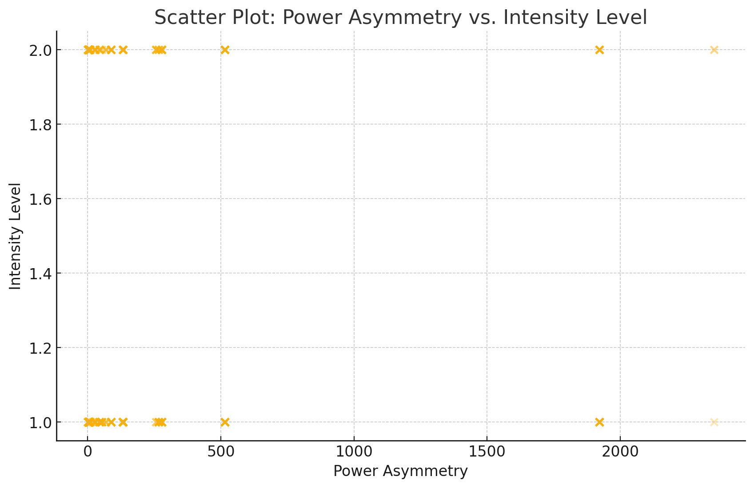

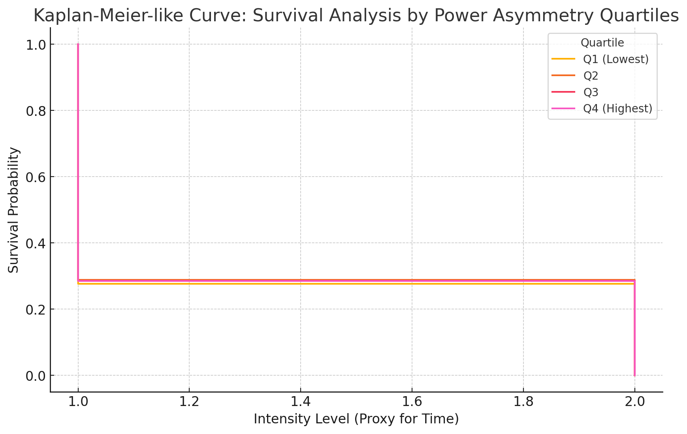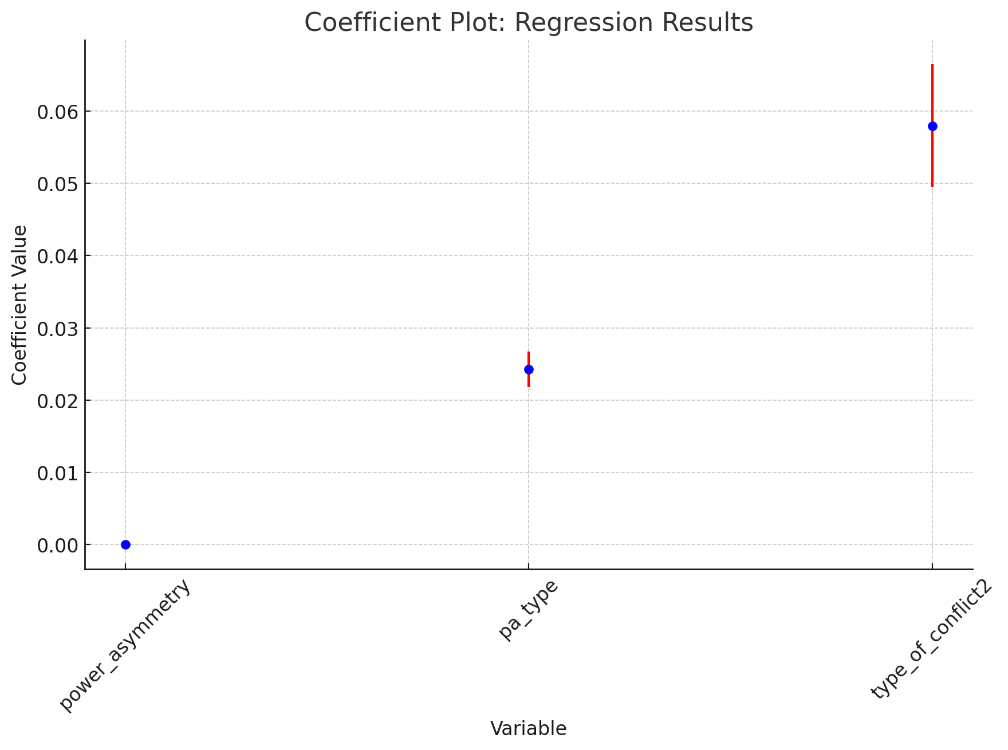
Empirical Results
Visualizations:
- Scatter Plot: Plots the Herfindahl Index against conflict intensity change. Results show a weak direct association, which points to other variables that may mediate this relationship. The scatter plot shows the overall relationship between power asymmetry and conflict intensity:
  - If the points cluster with higher intensity levels as asymmetry increases, it suggests that power asymmetry correlates with less effective conflict management.
  - On the other hand, no visible trend or clustering implies that power asymmetry has little to no practical effect on conflict intensity.
- Kaplan-Meier Curve: Shows that IOs with lower power asymmetry sustain peace agreements longer, with higher asymmetry IOs experiencing earlier breakdowns. Each curve represents a quartile of power asymmetry:
  - Higher quartiles (Q4 - highest power asymmetry) may show a faster drop-off in survival probability, suggesting greater instability or faster decay of intensity levels.
  - Lower quartiles (Q1 - lowest power asymmetry) might maintain higher probabilities over time, indicating greater stability.
- Coefficient Plot (Regression Results): The regression analyses highlight that while power asymmetry’s direct effect on initial mediation success is modest, it becomes more noticeable in predicting agreement longevity. Agreement type and conflict type exhibit more immediate, statistically significant effects on mediation outcomes, but when looking at long-term stability, higher power asymmetry correlates with greater likelihood of agreement collapse.
  - Power Asymmetry: A near-zero coefficient with a wide error bar suggests a weak and statistically insignificant effect on conflict intensity.
  - Peace Agreement Type (pa_type): A positive coefficient with a narrow error bar indicates a significant relationship, suggesting certain agreement types are associated with higher intensity levels.
  - Conflict Type (type_of_conflict2): Another significant and positive relationship, indicating that conflict type strongly influences intensity.
Overall, the data partially support the hypothesis. While power asymmetry is not always decisive in achieving an initial peace settlement, it becomes more influential in how long settlement lasts.

Discussion
The findings show the complexity of IO mediation. Although initial agreement success may be driven by immediate conflict characteristics and the type of agreement, the long-term durability of peace appears more susceptible to internal IO power dynamics. An IO dominated by a few powerful states may facilitate a quicker settlement, sometimes incentivized through coercion of a major power, but the resulting peace is often not stable and would have a tendency to reemerge. Conversely, IOs with more balanced power structures and neutral decision processes foster credibility, encouraging warring parties to trust the mediated settlement. Alternative explanations, including resource constraints or inherent difficulties of certain conflict types, remain plausible. When attempting to control for these factors, we find that while conflict characteristics and resource availability remain critical, the internal architecture of the IO itself exerts an independent influence on how well a peace agreement endures.

These insights have implications for policy and institutional design. Enhancing mechanisms to ensure more equitable power distributions, such as weighted voting systems that prevent a single state from dictating terms, could improve the sustainability of mediated settlements. Stronger policy decisiveness when dealing with conflict-tore states, more transparency in resource allocation, and more inclusive decision structures would help mitigate the risks associated with power asymmetries.

Conclusion
This study hopes to contribute a deeper understanding of how internal power dynamics within IOs shape their effectiveness in mediating civil conflicts. While initial outcomes like signing a peace agreement are often influenced by conflict type and agreement design, the durability of these settlements is more sensitive to the internal balance of power within the mediating IO. Greater power asymmetry is seen to be aligned with less stable post-conflict peace, highlighting the importance of equitable representation and balanced decision-making in international mediation forums.
Limitations include challenges in operationalizing “effectiveness” and fully capturing informal influence among IO members. Future research could explore qualitative case studies to understand how dominant states exert influence behind the scenes or incorporate network analysis to map informal power channels. Ultimately, reforming IO decision-making structures and improving the process of getting impartial institutional frameworks is likely to enhance the longevity of peace agreements and in-turn promote more enduring post-conflict stability.

References
- Abbott, Kenneth W., and Duncan Snidal. 1998. “Why States Act Through Formal International Organizations.” Journal of Conflict Resolution 42(1): 1–32.
- Boehmer, Charles, Erik Gartzke, and Timothy Nordstrom. 2004. “Do Intergovernmental Organizations Promote Peace?” World Politics 57(1): 1–38.
- Chu, Jung-Eun, and Amer Research Taqa. 2015. “The Role of International Organizations in Resolving Global Conflicts.” International Journal of Open Publication and Exploration 3(2): 26–32.
- Haas, Ernst B. 1983. “Regime Decay: Conflict Management and International Organizations, 1945–1981.” International Organization 37(2): 189–256.
- Kabore, F. 2023. “The Role of International Organizations in Conflict Management in Burkina Faso.” Journal of Conflict Management 3(1): 37–49.
- Lundgren, Magnus. 2016. “Conflict Management Capabilities of Peace-Brokering International Organizations, 1945–2010: A New Dataset.” Conflict Management and Peace Science 33(2): 198–223.
- Mele, Valentina, Simon Anderfuhren-Biget, and Frédéric Varone. 2015. “Conflicts of Interest in International Organizations: Evidence from Two United Nations Humanitarian Agencies.” Public Administration 94(2): 490–508.
- Wallensteen, Peter, and Isak Svensson. 2014. “Talking Peace: International Mediation in Armed Conflicts.” Journal of Peace Research 51(2): 315–327.
- Pevehouse, Jon C. W., Timothy Nordstrom, and Kevin Warnke. 2004. “The Correlates of War 2 International Governmental Organizations Data Version 2.0.” Conflict Management and Peace Science 21(2): 101–119.
- Högbladh, Stina. 2011. “Peace Agreements 1975–2011: Updating the UCDP Peace Agreement Dataset.” In Pettersson, Therése & Lotta Themnér, eds., States in Armed Conflict 2011, Department of Peace and Conflict Research Report 99, Uppsala University, pp. 39–56.
- Gleditsch, Nils Petter, Peter Wallensteen, Mikael Eriksson, Margareta Sollenberg, and Håvard Strand. 2002. “Armed Conflict 1946–2001: A New Dataset.” Journal of Peace Research 39(5): 615–637. Uppsala Conflict Data Program (UCDP). “UCDP/PRIO Armed Conflict Dataset.” Department of Peace and Conflict Research, Uppsala University.

